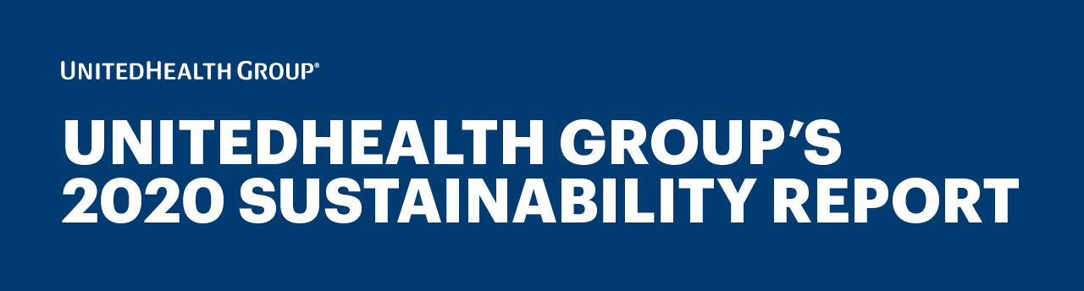
Dear [recipient first name],

I’m pleased to share UnitedHealth Group’s 2020 Sustainability Report. Sustainability is an extension of our business strategy, culture and mission as we work to help ensure the health care system works better for everyone.

Within the pages of this report, you will find a comprehensive and transparent description of our efforts to improve health care for all people and positively impact society.

Through stakeholder engagement – including customers, employees, shareholders, consumers, health care professionals, government officials and others – and input from leaders across the company, the report includes the following material topics that guide our ongoing approach to sustainability:

HELPING TO CREATE A MODERN, HIGH-PERFORMING HEALTH SYSTEM
We are committed to a future that expands access to care, improves health care affordability, enhances the health care experience and achieves better health outcomes. Partnering with key stakeholders, we are advancing health equity, building healthier communities and supporting the ongoing response efforts to COVID-19. Learn more

OUR PEOPLE AND CULTURE
We celebrate our people, ideas and experiences, creating a culture where all team members are appreciated, valued and able to reach their full potential. We join together as individuals – forming a team as diverse as the people we serve – in meeting our responsibility to improve the health system. Learn more

RESPONSIBLE BUSINESS PRACTICES
For more than 40 years, we’ve focused on developing strong and effective governance practices through compliance, board diversity and independence, a commitment to ethics and integrity, and an emphasis on data security and supply chain management. Learn more

ENVIRONMENTAL HEALTH
We recognize the important role the environment plays in the health of every community, and we are committed to mitigating our impact on the environment. Learn more

New to this year’s report is a dedicated chapter on advancing health equity, as well as increased transparency of our performance data. Additionally, we have introduced Long-Term Commitments that reflect our focus and determination to fulfill our mission and business strategy. Specifically, we are making commitments that:

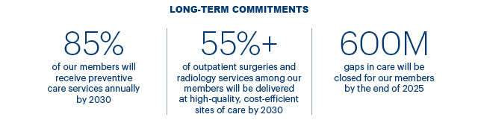

I hope you find the report valuable and informative, and welcome any questions or feedback you
might have.

Sincerely,

[NAME]
[TITLE]
[ORGANIZATION]

